Genetic Algorithm Project

In the Real world, living beings changed generation by generation. In computer world, natural selection can be modeling by genetic algorithm. By GA we can find that after adjust to the environment how mutation and crossover changed the chromosome.

This project is aim to know how Chromosome changed and after adjust fitness, what is every Generation's best chromosome and current chromosome. By check function value we can find that the difference between best and current, also we can know the difference between first generation and the other generations.

In this project, we generate the data of No.100 group to show that.

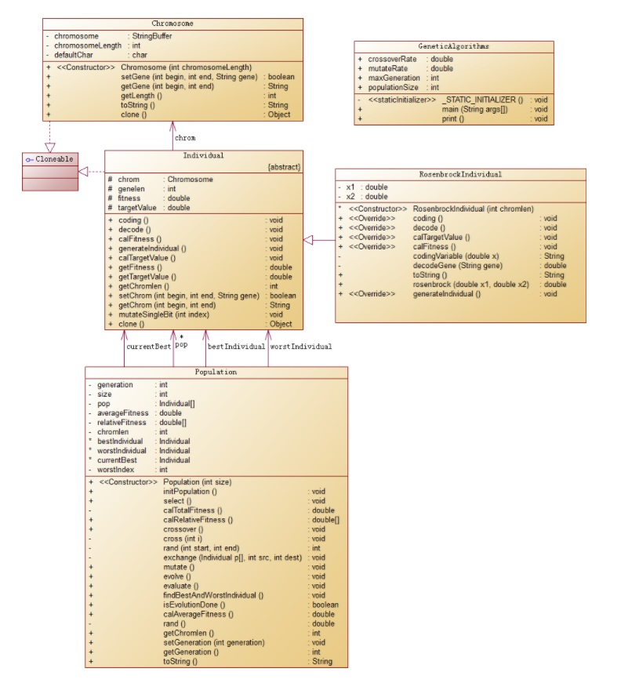

UML Of GA Project.

Unit Test Screenshot:

Chromosome Test:

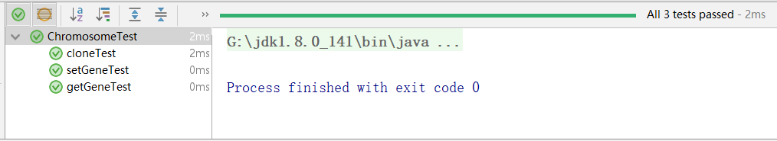

Population Test:

Rosenbrock Test:

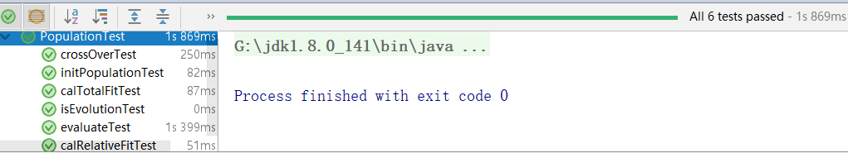

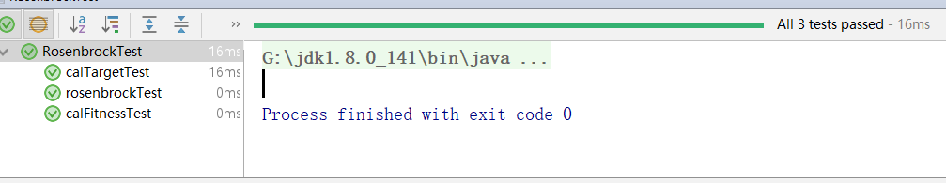

Main Test:

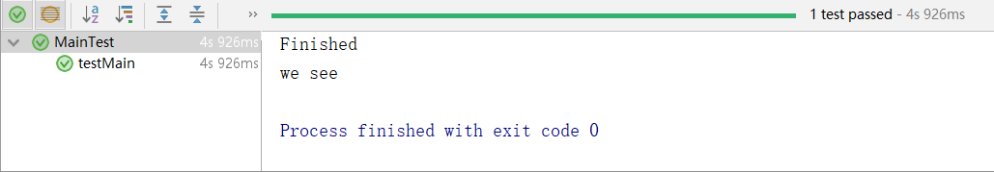

Difference between 1 generation group and 100 generation group

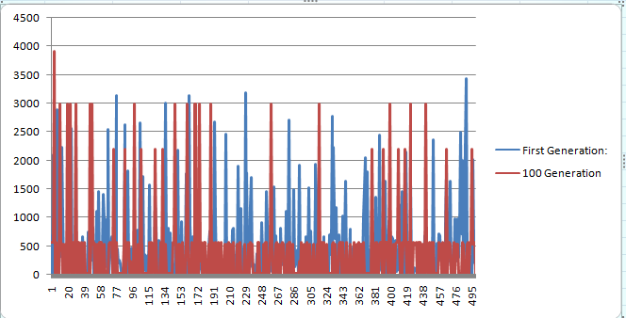

In one generation what the best should be and what the current best is. We can see in next table:

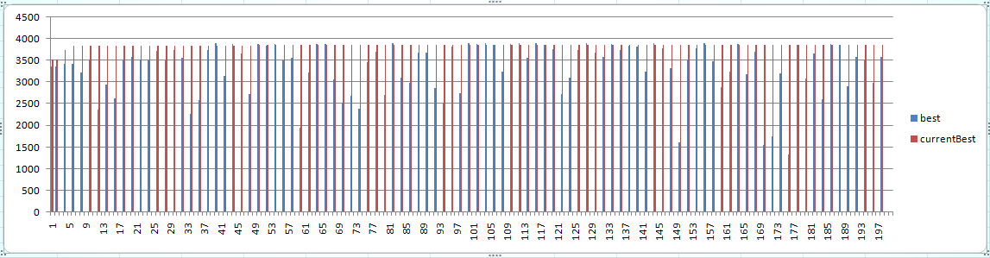

Result.txt

Attached with report.